**How SBTi Uses Climate Science**

*SBTi uses the latest science, guiding companies to lead on climate action*

**Contents**

**Exec Summary: The science in science-based targets 2**

**Deep-dive: An Extended Version of How SBTi uses Science to enable corporate climate actions. 7**

**Step 1 and 2: Understanding temperature goals and carbon budgets 7**

**Step 3: Selecting Pathways 9**

Step 3.1 Key Guiding Principles of Pathway Selection 9

Step 3.2. Synthesizing pathways from scientific sources 12

Step 3.3. Harmonizing recent emissions 14

Step 3.4. Translating Pathways into corporate climate targets using updated science-based methods 14

Step 4: Allocating emissions to Company GHG Scopes 16

**Step 5: Corporate level claims 16**

. 19

# Executive Summary

**The latest climate science sends a clear warning that the world must dramatically curb temperature rise to avoid the catastrophic impacts of climate change.** According to climate data, the world has warmed by almost 1.3 degrees Celsius relative to pre-industrial levels, with 2023 recorded as the hottest year in history. Global emissions must peak soonest and be cut by almost half in only seven years ' time to align with the Paris Agreement goal[1].

Science-based targets (SBTs) provide a clearly defined pathway for companies that is consistent with the rates of reduction and the actions prescribed in climate pathways which align with the temperature goal of the Paris Agreement – limiting global warming to 1.5°C above pre-industrial levels. SBTs, therefore, translate the action required at the global level to individual corporates and their specific economic activities.

The Science Based Targets Initiative (SBTi) is a corporate climate action organization that enables companies and financial institutions worldwide to play their part in combating the climate crisis. The SBTi develops standards, tools, and guidance that allow companies to set GHG emissions reduction targets in line with what is needed to keep global heating below catastrophic levels and reach net zero by 2050.

**Developing corporate science-based targets from complex scientific findings requires a structured yet adaptable approach that translates evolving climate science into actionable, measurable emissions reduction strategies**. SBTi develops methodologies that translate the latest physical climate science, aligning companies with the urgency of transformation required for credible climate commitment. This process adopts the 1.5C temperature goal and the best estimate of the remaining carbon budget for a 50% likelihood of staying within its limit. SBTi synthesises low-emission pathways that not only constrain cumulative emissions but reflect some key principles: low reliance on uncertain removals, address equity concerns, prioritize early mitigation actions and uphold sustainable developmental goals. SBTi’s standard development process includes sector-specific pathways that provide guidance on decarbonization strategies, aligning corporate emission reductions across Scope 1, 2, and 3 with 1.5°C-compatible trajectories. However, corporate claims associated with these emission scopes differ. Scope 1 claims, which cover direct emissions from a company’s operations, must align with the cumulative emissions trajectory prescribed by the relevant sectoral decarbonization pathway. Scope 2 claims, which account for purchased electricity, involve an additional complexity: multiple companies can claim reductions from the same decarbonized grid, necessitating an approach that adapts for shared progress. Scope 3 claims present the greatest challenge, as companies have less direct control over emissions from their value chain, requiring coordinated efforts across industries to ensure real reductions rather than shifting emissions elsewhere.

**Science evolves, and so must corporate targets.** Recent findings indicate a further reduction in the estimated remaining carbon budget[2], driven by improved historical emissions data, higher-than-expected ongoing emissions, refined assessments of aerosol effects, and advances in climate modeling. This means companies must continuously align their mitigation actions to reflect climate urgency. The shrinking carbon budget raises concerns about the credibility of corporate 1.5°C-aligned targets. As the budget depletes, companies must accelerate near-term emissions reductions to align with the latest climate science. Without stronger action, many targets risk becoming misaligned with a truly 1.5°C-consistent trajectory. SBTi uses specific methodologies to reflect evolving physical science understandings to corporate climate targets, including harmonising recent global emissions and correcting interim company-level budget overshoot.

**Is the 1.5C still a realistic temperature goal, and what are the implications on the credibility of corporate targets?** The feasibility of limiting global warming to 1.5C is increasingly in question as recent estimates suggest that at current emission rates, the budget could be exhausted in less than a decade. However, while the probability of a 1.5C goal diminishes, the goal remains a critical benchmark for corporate climate action. There is increasing scrutiny about the credibility of corporate 1.5C claims for companies that would set targets in a later period. Key concerns include whether late starters can feasibility align with 1.5C pathways, the fairness of their emission allowance compared to early movers, and the requirement of steeper reduction to compensate for their contribution to budget depletion due to delayed action.

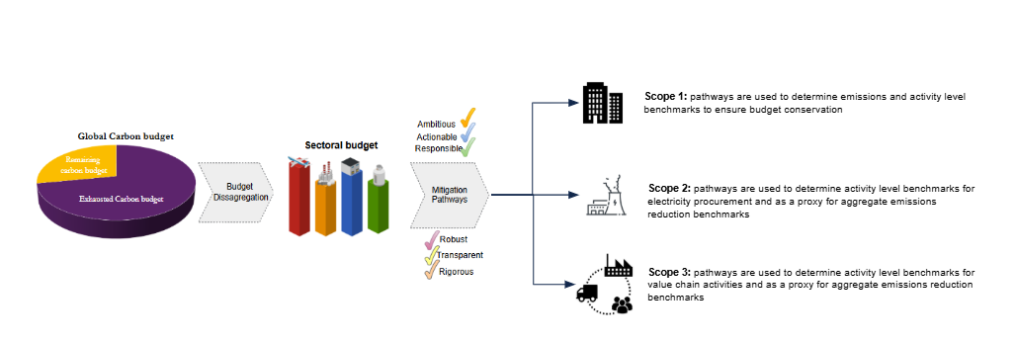

**Steps for designing SBTs**

As the window to stabilise global temperatures below 1.5°C narrows and the effects of small temperature increases become clearer, the case for strengthening climate ambition becomes urgent. Equally important is turning this ambition into concrete action that lowers GHG accumulation in the atmosphere. SBTi uses the latest scientific evidence, including carbon budget assessment, climate pathways and sector-specific feasibility, to develop rigorous standards that align companies’ actions with the most ambitious mitigation pathways. near-term mitigation pathways. There are four key steps that SBTi follows in translating the latest science to company-level climate targets, as well as validating corporate temperature claims:

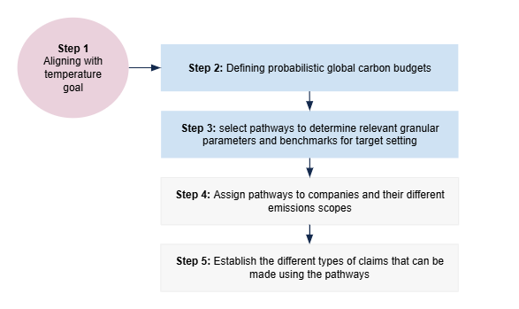

1. **Aligning corporate climate action with Paris Agreement temperature goals:** The Paris Agreement establishes a temperature goal of well-below 2C while pursuing efforts to limit warming to 1.5C, reflecting scientific consensus on the risks of exceeding these thresholds. While temperature goals remain fixed as policy benchmarks, the carbon budget for achieving them is a dynamic estimate based on climate science.
2. **Estimating probabilistic carbon budgets for specific temperature targets:** each temperature goal has an associated carbon budget, which reflects the quasi-linear relationship between cumulative emissions and temperature rise. The carbon budget associated with specific temperature outcomes evolves with refinements in climate sensitivity estimates, earth system feedbacks, and the influence of non-CO₂ forcers. The IPCC synthesises the latest scientific literature, leading to adjustments in assessed budgets over time. The shift from AR5 (2014) to SR15 (2018) introduced significant methodological improvements, resulting in notable budget revisions. AR6 (2021) further refined uncertainties but did not introduce drastic changes to budget estimates. However, more recent analyses indicate that the remaining carbon budget is depleting faster than previously assessed due to ongoing emissions and emerging feedbacks
3. **Assessing emissions pathways within a carbon budget** :

The scientific community develops scenarios that explore how emissions could be reduced over time across different sectors and regions in ways consistent with a given carbon budget. These scenarios explore potential emissions pathways across different sectors, reflecting assumptions about technology deployment, policy choices, and economic trends. These scenarios provide indicative sectoral trends and technology adoption rates, such as projected shares of electric vehicles, based on model assumptions and constraints.

1. **Applying scenario-based benchmarks to a company’s emission scopes**: SBTi derives sector-specific decarbonization pathways to determine the necessary emission reduction rates for companies. Importantly, reduction rates are applied differently to each emissions scope
   1. Scope 1: Scope 1 covers direct emissions from owned or controlled sources. While these emissions are not double-counted in other entities' Scope 1 inventories, they may appear in other organisations' Scope 3 emissions. Sector-specific pathways determine the rate at which companies must reduce emissions from their assets, either through efficiency improvements, fuel switching, or asset retirement.
   2. Scope 2: Scope 2 covers emissions from purchased electricity, which are typically double-counted between electricity producers and consumers. Companies must align their electricity procurement with decarbonization pathways by increasing the share of zero-carbon electricity while also considering efficiency measures to reduce electricity demand.
   3. Scope 3: Scope 3 includes indirect emissions from upstream and downstream activities, often comprising the largest share of a company's footprint. While these emissions appear in multiple organizations’ inventories, this reflects value chain interdependencies. Scenario pathways guide the rate at which companies should engage suppliers, decarbonize product portfolios, and align investment strategies to drive emissions reductions across their value chain.
2. **Generating credible claims that respond to and incorporate shifting scientific insights and consensus**
   1. **Claims based on a pathway:**  `Scope 1 claims` must align with the cumulative emissions trajectory prescribed by the sectoral decarbonisation pathway. Companies are assessed not solely on achieving an endpoint reduction target but on maintaining emissions within their allocated share of the sectoral carbon budget over time, relative to the reference year of the pathway.

`Scope 2 claims` account for the fact that multiple companies may claim emissions reductions from the same decarbonized electricity sources (e.g., renewable energy purchased through Power Purchase Agreements (PPAs) or Renewable Energy Certificates (RECs)). Therefore, alignment with a 1.5°C pathway implies that reductions should be additional and verifiable. A company’s claim should reflect its actual contribution to energy sector decarbonization rather than benefiting from reductions that would have occurred independently.

Scope 3 emissions appear in multiple companies’ inventories because they are shared across value chains, reflecting interdependencies in emissions reporting. Because a supplier’s Scope 1 emissions can also be a buyer’s Scope 3 emissions, claims of alignment with a 1.5°C pathway must go beyond accounting adjustments. Companies should demonstrate that their Scope 3 reductions are credible by working with suppliers, customers, and industry groups to drive systemic decarbonization rather than relying solely on shifts in accounting or supplier-reported reductions.

**(b) Maintaining corporate temperature alignment under a shrinking carbon budget:** The global temperature target corresponds to a remaining carbon budget that limits cumulative net emissions to maintain a given probability of staying below a specific warming threshold. At the company level, a temperature alignment claim reflects a commitment to a defined GHG reduction pathway linked to a specific global warming limit, such as 1.5°C. These claims are based on the company’s share of the sectoral carbon budget, typically allocated from a specific reference period. (e.g., from 2020 onwards).

Corporate temperature alignment is assessed based on a company’s adherence to its science-based decarbonization pathway and associated benchmarks. Scope 1 alignment requires maintaining reductions within the company’s allocated share of the sectoral carbon budget. Scope 2 and Scope 3 alignment is based on meeting sector-specific activity-level benchmarks, such as renewable electricity procurement and value chain decarbonization. Alignment claims remain valid as long as these conditions are met, regardless of external factors such as insufficient mitigation by other actors

As scientific assessments revise the remaining carbon budget, companies may need to accelerate emissions reductions to maintain alignment with temperature goals. This can result in adjustments to sectoral decarbonization pathways, leading to more stringent activity benchmarks and ambition levels. Even if a company’s alignment claim remains valid under its original pathway, it may need to strengthen its targets and accelerate reductions to stay within a shrinking carbon budget. This requires revising corporate targets and implementation strategies to align with updated pathway benchmarks, ensuring reductions remain within the revised budget constraints.

# Deep-dive: An Extended Version of How SBTi uses Science to enable corporate climate actions.

## **Step 1: Aligning corporate climate action with 1.5C temperature goal**

**Before the Paris Agreement, global climate efforts lacked a unified framework for limiting warming levels.** While earlier agreements like the Kyoto Protocol set emission reduction targets, Paris was the first to establish a near-universal commitment to a temperature goal informed by science. The 1.5°C target emerged from scientific assessments comparing climate impacts at different warming levels. The IPCC found that at 1.5°C, extreme heat events are projected to occur far less frequently than at 2°C, reducing the risks of heat-related mortality, crop failures, and infrastructure stress, particularly in vulnerable regions [3]. Therefore, the Paris Agreement establishes a legally binding framework for state actors while encouraging voluntary commitments from non-state actors, collectively setting a `defense-line` against climate risks. **The 1.5°C target serves as a critical threshold to minimize catastrophic risks.**

The private sector has a critical role to play in ***keeping the 1.5C alive***, with SBTi providing science-based frameworks to guide companies in setting credible, ambitious emissions reduction targets in line with this overarching goal. The business case for a 1.5°C goal is obvious: a 1.5°C world is a world that is more economically stable. For businesses, it provides more secure supply chains that are less susceptible to flood and extreme weather risks, healthier and safer workforces that are less exposed to extreme heat, water scarcity and food shortages, and stable operations that are significantly less at risk of dramatic changes[4].

**How does the breach of the global 1.5C target affect SBTi corporate alignment?** Even though there is likelihood of breaching global 1.5C goal, the value of corporate alignment to the Paris agreement remains valuable. Achieving the 1.5C goal requires that all universe acts in unison, however, this is not the current reality. Therefore, SBTi separates the global feasibility of 1.5C from its role in corporate target-setting, otherwise, corporate target becomes a moving target, dictated by external feasibility constraints rather than the science of what is needed to limit warming to 1.5°C. Sticking to the 1.5°C pathway provides a clear and ambitious goal for companies, encouraging urgent and sustained action, regardless of how challenging the global outlook becomes.

# **Step 2**: **Estimating probabilistic carbon budgets for specific temperature targets**

**How the world gets to a 1.5C goal is as important as meeting the mark.** Limiting global warming to 1.5°C means the world should reach net-zero CO₂ emissions by around 2050. However, the timing alone is not enough. The total emissions released before net-zero (cumulative emissions) determine peak warming, which in turn drives the severity and frequency of climate disasters such as extreme heatwaves, storms, and sea-level rise.

The global carbon budget concept defines the total allowable emissions needed to stay within a given temperature limit like the 1.5C. Derived from authoritative sources such as the IPCC, it serves as a foundational benchmark for assessing whether emission pathways align with the temperature goal (Box 1). The SBTi currently aligns its pathways with the IPCC estimates, specifically using the AR6 carbon budget[5]. The IPCC estimates a carbon budget of 500 GtCO₂ from 2020 onward for a 50% chance of limiting warming to 1.5°C with low or no overshoot. However, with emissions continuing to rise rather than peak, the available budget is halved as of 2024 [6].

**How does SBTi respond to a shrinking budget from a quantitative perspective?** SBTi’s pathways are based on IPCC AR6 scenarios and selected peer-reviewed literature (like the IEA), but it does not independently model the depletion of the remaining carbon budget. Instead, SBTi applies a harmonization framework to address the reality of emissions not peaking as modelled in IAM[7] scenarios. This mechanism accelerates the emission reduction rate, and refines the timing of key sectoral transformations, ensuring targets remain 1.5°C aligned.

**Each year, the budget is “used up”, meaning there is less emissions space available to stay within the desired temperature goal**. As such, companies` compatibility with a temperature target is not static but rather associated with the remaining carbon budget as delineated from pathway revisions. To maintain corporate alignment, earlier and steeper corporate target ambitions may be required.

|  |
| --- |
| **Box 1: Global Carbon Budget**  The global carbon budget is the cumulative CO₂ emissions that can be released to limit global warming to 1.5°C or 2°C above pre-industrial levels. The carbon budget concept relies on a quasi-linear relationship between cumulative emissions and temperature rise. Climate models, such as those used by the IPCC, estimate how much CO₂ can be emitted before exceeding key warming thresholds like 1.5°C or 2°C.  This budget is calculated based on several factors, including climate sensitivity (how much warming results from a given amount of CO₂), historical emissions (the CO₂ already released since the industrial era), and the influence of other greenhouse gases and aerosols that affect the climate system. However, the carbon budget is not static but rather shrinks as emissions continue, meaning that every year of continued fossil fuel use depletes the remaining budget. Scientific updates, such as better estimates of climate sensitivity or stronger-than-expected carbon cycle feed backs (e.g., permafrost thawing, reduced ocean CO₂ absorption), can further revise the available budget. If emissions remain high, the budget could be exhausted sooner than expected, making it much harder to limit warming.  According to the IGCC report on the 1.5C target, the atmosphere can absorb, calculated from the beginning of 2024, no more than 200 gigatonnes (Gt) of CO2 if we are to stay below the 1.5°C threshold. However, this doesn't imply that the Earth will immediately reach 1.5°C of warming when the remaining budget to stay below that threshold is exhausted. This is because there is a delay between the accumulation of emissions in the atmosphere and the impact on temperature rise.  Source: [ClimateChangeTracker](https://climatechangetracker.org/igcc/current-remaining-carbon-budget-and-trajectory-till-exhaustion) |

Box 2 highlights the key terminology that SBTi employs.

|  |
| --- |
| **Box 2: Carbon budget and net-zero**  "**Net Zero**" refers to the point where global CO₂ emissions are fully balanced by removals. This balance stabilizes global temperatures and is a key milestone in limiting warming to 1.5°C in most IPCC-reviewed scenarios. To stay on track, global CO₂ emissions must reach net zero by around mid-century, with further reductions in other greenhouse gases required to achieve full climate neutrality. Since long-term global temperature rise is primarily driven by cumulative CO₂ emissions, achieving net zero requires staying within the remaining carbon budget. The longer net zero is delayed, the faster the budget is depleted, pushing temperatures higher and increasing the risk of overshooting 1.5°C. Once the budget is used up, any additional emissions requires large-scale carbon removal, which remains highly uncertain at scale.  "**Paris-aligned**" refers to an emissions trajectory that limits global warming well below 2°C, with efforts to stay within 1.5°C, as outlined in the Paris Agreement. A trajectory is considered Paris-aligned if it follows a pathway consistent with the remaining global carbon budget required to achieve these limits, based on the latest climate science. **“1.5C aligned”**: a subset of Paris-aligned and specifically refers to pathways that follow a carbon budget consistent with limiting warming to 1.5°C with no or limited overshoot. Unlike broader Paris-aligned trajectories, which allow for warming up to well below 2°C, a 1.5°C-aligne**d** pathway requires faster and deeper emissions reductions to stay strictly within the 1.5°C threshold  A company can reach net zero without being Paris-aligned, depending on their total cumulative emissions before reaching net zero. If they achieve net zero while staying within the carbon budget, they remain aligned (Scenario A). However, if they reach net zero after exceeding the budget , they contribute to higher peak temperatures and must take corrective action to realign with 1.5°C (Scenario B). Realigning after overshoot requires both steeper emissions reductions and removals. Companies must accelerate their reduction rate beyond initial targets to cut emissions faster than originally planned. At the same time, CO₂ already released into the atmosphere must be actively removed.  **SBTi`s implementation of these Concepts**   * The SBTi requires companies to reach net-zero by 2050 with clearly defined interim reduction targets. * The volume CO2 removal required at the point of net-zero to neutralize difficult-to-abate emissions should be planned for, given the current slow scaling of removal technologies. * SBTi requires companies to set interim removal targets such that by by the net-zero year, 100% of their remaining emissions is completely neutralized[8]. * The SBTi requires that for companies to be Paris-Aligned, company-level interim carbon budget should be conserved on a 5-year interim basis. If companies overshoot these constraints, a correction mechanism is applied, increasing the next cycle`s target ambition.   (a)  (a) (b) |

## **Step 3: Selecting Credible Pathways**

**3.1. Pathways are needed for multiple purposes:**

1. To define how the remaining carbon budget is allocated over time for alignment with a 1.5°C pathway and avoid exceeding critical thresholds
2. To establish sector-specific benchmarks for high-emitting activities, providing clear performance targets at key milestones on the path to net zero
3. Tracking transformational progress and allowing for adjustments based on real-world emissions trends.

The SBTi follows a structured strategy in selecting pathways used in sector-specific and agnostic standards[9] (Figure below). The steps followed in SBTi`s pathway synthesis process are explained in subsequent sections, presented in the figure below.

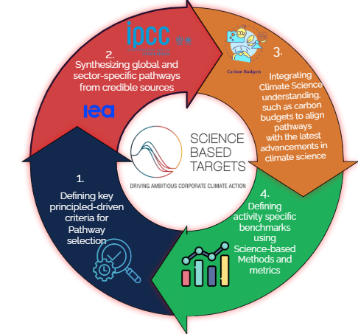

See [Pathway Explorer](https://pathway-database.streamlit.app/) for sector-specific pathways

**3.2. Pathway selection based on key principles**

At the core of the SBTi’s scientific approach is a set of guiding principles that define how pathways are selected across the scientific literature. These X principles—Ambitious, Responsible, Rigorous, Actionable, Robust, and Transparent—guide the SBTi's pathway development, ensuring alignment with the latest advances in climate science and driving meaningful corporate actions

*Ambition* is the primary principle for SBTi`s pathway selection. The principle constrains pathway development to only scenarios that limit warming to 1.5°C with low or no overshoot, aligning corporate climate action with the latest scientific recommendations and driving timely, transformative action.

The principle of ambition is balanced with *Responsibility*. The SBTi framework emphasises a just and equitable transition to a net-zero future that minimises the risk of adverse outcomes for broader sustainability objectives. Operationalizing this principle not only addresses climate mitigation but also prioritizes pathways that adopt wider sustainable development goals and respect planetary boundaries. The SBTi prioritizes mitigation scenarios that support biodiversity, equitable resource use, and global development while minimizing negative impacts.

The SBTi's methodological framework hinges on scientific *Rigour* by developing pathways that are scientifically robust and credible. The *Actionability* principle ensures pathways are based on credible projections of key socio-economic factors, such as population growth, economic trends, and technological advancement. SBTi maintains the actionability of its pathways through periodical updates to reflect evolving scientific knowledge, socio-economic trends, and technological advancements.

The *Robustness* principle emphasizes internal consistency and logical coherence. Pathways should align with established scientific frameworks, transparent assumptions and scientifically credible methodologies. The principle of *Transparency* implies that Pathways rests on methods, scenarios, and assumptions that are publicly accessible.

Guided by these principles, the SBTi has developed quantitative criteria that inform the inclusion or exclusion of scenarios in pathway development, presented in Table XX. These criteria establish clear filters for selecting pathways that align with its scientific and sustainability objectives. Future updates to SBTi pathways will maintain these filters as part of its sector-specific standard development process.

**Key scientific thresholds used when selecting pathways**

Add overview of why these 6 thresholds are important (Table XX):

|  |  |  |  |
| --- | --- | --- | --- |
| **Criteria** | **Value** | **Limit** | **Reference** |
| Primary energy from bioenergy in any year between 2010-2050 | 100 EJ | Upper | Frank et al., 2021 |
| CO2 removed via BECCS in any year between 2010-2050 | 3 GtCO2 | Upper | Warszawski et al. 2021 |
| CO2 removed via afforestation in 2050 | 3.6 GtCO2 | Upper | Fuss et al., 2018 |
| Cumulative CO2 permanently stored in geological deposits, 2010-2050 | 214 GtCO2 | Upper | van de Ven et al., 2023 |
| CO2 removed via novel CDR in 2020 | 2.3 MtCO2 | Upper | Smith et al., 2023 |
| Cumulative AFOLU emissions, 2020-2050 | -99.54Gt CO2e | Lower | SBTi, 2022 |

**3.3. Synthesizing pathways from scientific sources**

**Sources used for scenario selection**

The SBTi synthesises available data from scientific sources to identify credible and updated pathways. The SBTi evaluates scenarios based on their alignment with key guiding principles. This synthesis scope covers credible institutional scenarios in the grey literature, like the International Panel for Climate Change (IPCC) and the International Energy Agency (IEA). The IPCC and IEA scenarios are central to current SBTi sectoral pathways for certain reasons:

* **Rigorous vetting and scientific consensus**: The IPCC and IEA pathway development follow rigorous vetting processes, consensus-driven insights from leading experts, and comprehensive coverage of global and sector-specific emissions trajectories, carbon budgets, and mitigation strategies.
* **Periodic Updates Reflecting Advancements in Climate Science:** The IEA and IPCC periodically update scenarios to reflect advancements in climate science, further reflecting their relevance and reliability as foundational inputs for SBTi pathway development.
* **Coverage of Carbon Budgets and Mitigation Pathways:** The IPCC and IEA scenarios provide granular insights into global and sector-specific emissions trajectories, allowing SBTi to develop pathways tailored to different industries. These scenarios outline carbon budgets consistent with limiting global warming to 1.5°C, helping companies understand their fair share of emissions reduction
* **Institutional Authority and Policy Influence:** The IPCC and IEA are the primary references for policymakers, regulators, and international climate agreements (e.g., the Paris Agreement). By relying on these authoritative sources, SBTi strengthens the credibility of corporate climate targets, reducing the risk of greenwashing and ensuring alignment with global climate objectives.

The SBTi considers peer-reviewed research complementary to these foundational inputs. The SBTi evaluates focal studies based on the transparency of its methodologies, alignment with established climate science, and robustness of assumptions. Furthermore, we validate peer-reviewed literature using institutional scenarios to ensure consistency and to identify areas where cutting-edge insights may enhance or refine existing pathways. The pathway synthesis also covers different modelling approaches, which use either top-down models, bottom-up models, or a hybrid of both[10].

**Scenario granularity: Regional**

In SBTi`s sector standard development, the choice between a global or regional pathway hinges on three fundamental criteria. A regional pathway is only adopted if all three conditions are met. Otherwise, a global pathway ensures methodological consistency and avoids uncertainty in carbon budget allocation

1. Data sufficiency: High-resolution, regionally disaggregated data on emissions sources, energy systems, and mitigation potential must be available to ensure credible modelling and scenario development. Without sufficient granularity, a regional approach introduces uncertainty and potential misalignment with observed sectoral trends. *Decision: If robust, validated regional data exist, a regional pathway is considered. Otherwise, a global pathway is used to prevent methodological inconsistencies.*
2. Carbon budget conservation: A regionally differentiated pathway should not lead to a misallocation of the global carbon budget. The cumulative emissions trajectory should align with global net-zero objectives, ensuring that disaggregated regional targets do not collectively exceed the remaining carbon budget. *Decision: If regional differentiation maintains carbon budget integrity and enhances mitigation feasibility, it is preferred. Otherwise, a global approach is required to ensure compliance with carbon budget constraints*
3. Equity considerations: Fair burden-sharing is critical in emissions reduction pathways. Regional pathways should account for historical emissions, economic capacity, and technological readiness to ensure that mitigation efforts align with principles of climate justice and differentiated responsibilities. *Decision: It is justified if regional differentiation promotes a just transition without disproportionately burdening any region. Otherwise, a global pathway is preferable to maintain uniformity in mitigation expectations.*

**Scenario granularity: Harmonizing recent emissions**

Recognising that global emissions have not peaked as projected in many mitigation scenarios, SBTi addresses this gap by harmonizing IPCC scenarios with recent emissions. This approach may imply steeper mitigation actions in the near term for any chance of staying in line with the 1.5C goal.

Therefore, pathways link the global carbon budget and company-specific targets (Figure 2).

Key guiding principles guiding pathway selection

|  |  |  |
| --- | --- | --- |
| **Principle** | **Description** | **Assessment Criteria** |
| Ambitious | Requires that entities decarbonise in line with the ambition required to limit warming 1.5°C with no or limited overshoot. | Pathways should align with 1.5°C scenarios with no or limited overshoot, demonstrating early, deep, rapid, and sustained emissions reductions. |
| Responsible | Requires a transition to net zero that emphasizes low risk of adverse outcomes for broader sustainability goals | Pathways should rest on conservative drivers of climate mitigation, emphasizing the low risk of adverse outcomes for broader sustainability goals, including relevant sustainable development goals and planetary boundaries. |
| Rigorous | Use the best available science from authoritative sources, such as the Intergovernmental Panel on Climate Change (IPCC), the International Energy Agency and similar or related sources, and best practices in climate target setting and climate mitigation at the time of standard development. | Pathways should be based on peer-reviewed literature or compiled by authoritative organizations like the IPCC and internationally recognized models, ensuring scientific integrity. |
| Transparent | Requires all relevant information is publicly available, and transparently documented, including explicit statements of assumptions and calculation procedures. | Pathways should disclose assumptions, data sources, and calculation methodologies, allowing for independent verification.  ility”, below). |
| Robust | Meaningfully represent the climate performance of an entity, and be consistent over time to enable credible claims throughout the target-setting and implementation journey while reaching for a maximum level of comparability across entities. | Pathways should be consistent, comparable, and subject to regular updates to reflect evolving science and policy developments. |
| Actionable | Requires all technical foundations to be practical to design and implement, leading to measurable action and progress in climate performance. | Pathways should include clear steps, timelines, and measurable milestones, ensuring practical implementation and tracking. |

##### 

## **Step 4: Applying scenario-based benchmarks to a company’s emission scopes**

To translate the global carbon budget into actionable company-level targets, the SBTi applies sector-specific 1.5°C-aligned pathways. These pathways provide benchmarks that guide science-based target setting, aligning corporate emissions reductions with science-based ambition levels. Since corporate emissions originate from different operational and value chain activities, their climate impact is categorized into three distinct scopes, which are fundamental to accurately measuring and setting reduction targets within the SBTi framework.(Figure X).

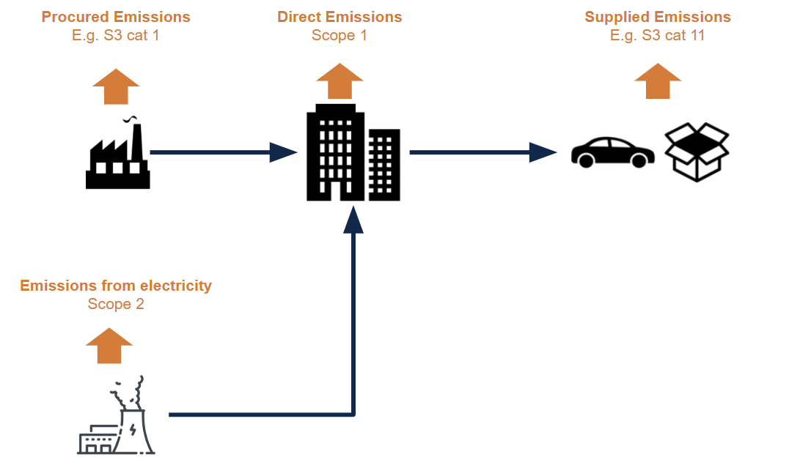

**To determine a science-based trajectory for an entity, pathway elements such as sector-specific emissions benchmarks, decarbonization rates, and mitigation strategies are applied differently across Scope 1, 2, and 3, reflecting their distinct emissions sources and reduction challenge:**

**Scope 1:**  Scope 1 emissions are direct emissions released into the atmosphere from an entity’s operations, including fuel combustion, industrial processes, and company-owned transport. These emissions are explicitly accounted for in carbon budget pathways, which define how Scope 1 reductions must align with 1.5°C-compatible trajectories. Pathways serve the following functions for scope 1:

* Defining sectoral emissions pathways – Sector-specific decarbonization trajectories establish how quickly companies must reduce their direct emissions, considering sectoral mitigation potential and technological feasibility.
* Establishing benchmarks for key milestone years – Performance targets include production-related metrics (e.g., emissions intensity of cement production) and procurement targets (e.g., share of zero-emission vehicles or electric arc furnace adoption in steel manufacturing).
* Informing sector-specific target setting – Pathways guide benchmark selection to align companies with the carbon budget and required emissions reductions

Scope 2: Scope 2 emissions are indirect emissions from purchased electricity, heat, and cooling used in a company’s operations. Pathways establish the pace at which companies must reduce electricity-related emissions, aligning with the power sector’s decarbonization trajectory. Pathways provide a structure approach for scope 2 target setting:

* The electricity sector’s emissions pathway serves as a benchmark, guiding how quickly companies must transition to zero-carbon electricity sources. Companies are expected to reduce emissions from their purchased electricity at a rate consistent with the power sector’s required reductions.
* At key milestones, companies must meet activity-specific benchmarks, such as the share of zero-carbon electricity procured or the emissions intensity of electricity consumed. Pathways provide a structured timeline for corporate electricity procurement strategies, ensuring alignment with the science-based transition to a decarbonized power system.

**Scope 3**: Scope 3 emissions are indirect emissions from a company’s value chain, covering both upstream (e.g., purchased goods and services, transportation) and downstream activities (e.g., product use, end-of-life disposal, and investments).

Pathways inform the pace at which companies must align procurement, revenue generation, and financing with low-carbon activities to meet reduction targets. While pathways can guide overall emissions reductions, their applicability to Scope 3 varies by sector due to differences in supply chain structures, data availability, and emissions reporting complexities.

Pathways also establish performance benchmarks for key value chain activities, such as supplier emissions intensity, investment portfolio alignment, and product lifecycle emissions reductions, ensuring that companies effectively integrate Scope 3 reductions into their climate strategies.

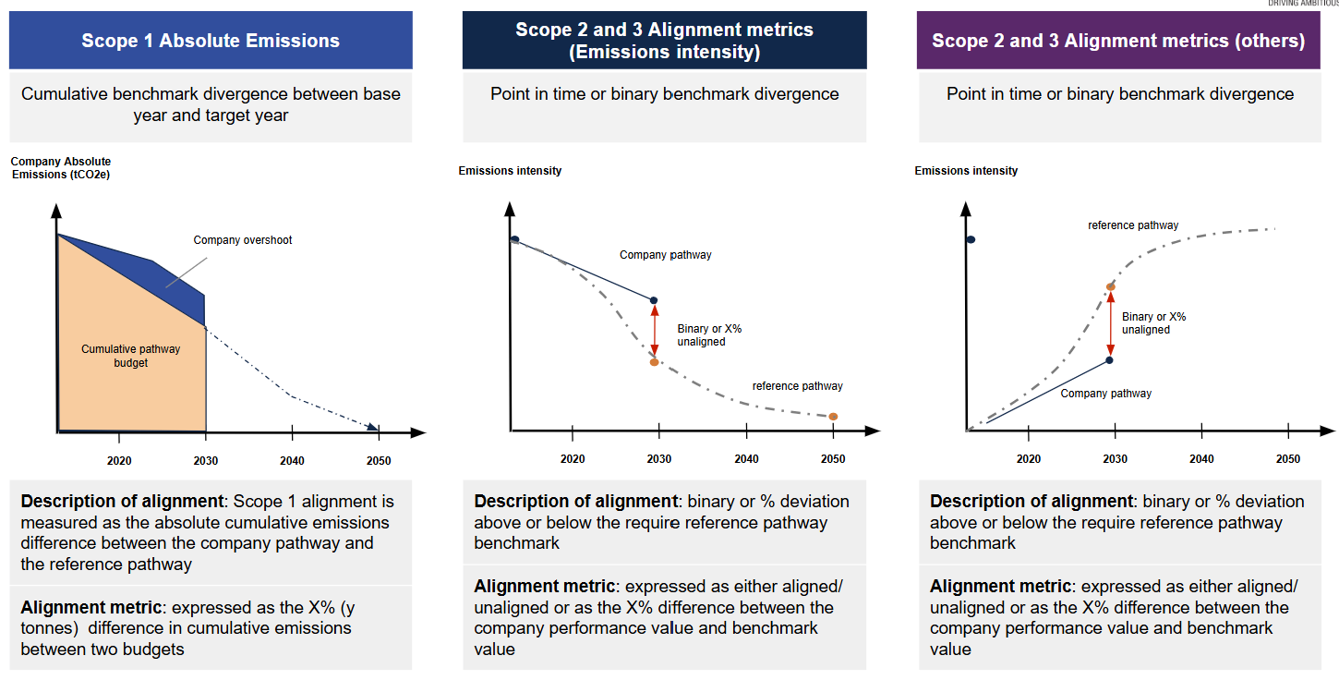

**4.1 Target-setting methodology**

**The SBTi refines its target-setting methodologies to align with evolving climate science and sectoral best practices. These methods establish interim emissions reduction targets, ensuring that companies follow a scientifically consistent net-zero trajectory.** Targets are set based on a company’s initial emissions profile, sectoral pathway, and activity-based benchmark for a 1.5°C-aligned pathway.

For Scope 1, SBTi’s methods aligns company-level emissions reductions with the remaining carbon budget for limiting warming to 1.5°C. These methods use sector-specific decarbonization pathways that account for projected activity levels and technological mitigation potential.To maintain alignment, SBTi incorporates interim target adjustments to correct for emissions overshoot, requiring accelerated reduction rates or additional mitigation measures if needed. If a company exceeds its allocated emissions within a given timeframe, the methodology enforces stricter near-term targets, requiring steeper cuts or supplementary mitigation actions to realign with the 1.5°C pathway (See Figure X below).

For Scope 2 and 3, target-setting methods define the emissions reduction trajectory companies must follow to align with 1.5°C pathways. These methods establish sector-specific performance benchmarks, such as the required share of zero-carbon electricity procurement (Scope 2) and supply chain emissions reductions (Scope 3). These benchmarks are derived from sectoral decarbonization pathways, ensuring alignment with the global carbon budget

*Figure 6*: Revision of methods models using recent scientific evidence

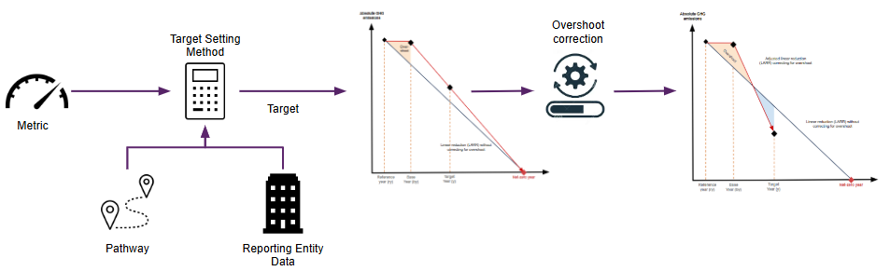

## **Step 5: Credible Corporate level claims**

**Claims based on a specific temperature outcome/pathway**

Corporate-level claims establish a clear connection between a global temperature goal and the underlying pathway(s) guiding ambitions. A company’s stated alignment with a temperature goal must be assessed based on long-term ambition and actual emissions performance on an interim basis. Table XX outlines key criteria for Scope 1, 2, and 3 alignment with 1.5°C pathways.

|  |  |  |
| --- | --- | --- |
| **Scope** | **Description** | **Claim** |
| Scope 1 | A 'science-based' or 1.5°C-aligned Scope 1 target requires a company to reduce its direct emissions at a rate consistent with the remaining carbon budget for its sector. | Claims can be classified as either 'budget-based' (reflecting adherence to a sector-specific emissions budget) or 'alignment-based' (indicating compliance with an intensity or absolute reduction benchmark in the target year) (See Fig below) |
| Scope 2 | A 'science-based' or 1.5°C-aligned Scope 2 pathway requires a company to progressively reduce emissions in line with sector-specific decarbonization benchmarks, aligning with the required benchmark value in the target year | Scope 2 claims are typically alignment-based, requiring companies to meet a defined emissions or activity-specific benchmark in the target year |
| Scope 3 | A 'science-based' or 1.5°C-aligned Scope 3 pathway requires a company to progressively reduce emissions in line with sector-specific decarbonization benchmarks, ensuring alignment with the required benchmark value in the target year | Scope 3 claims are typically alignment-based, requiring companies to meet a defined emissions or activity-specific benchmark in the target year.  Scope 3 claims are evaluated based on specific activity-level benchmarks rather than aggregated emissions reductions across the entire value chain.  Scope 3 can be budget-based in certain sectors, such as finance and oil & gas supply chains, through portfolio carbon budgets (e.g., banks capping financed emissions), supplier engagement quotas (e.g., requiring a percentage of suppliers to be net-zero), and product lifecycle CO₂ caps (e.g., limiting the total emissions impact of sold products). |

Corporate climate claims can be framed as either 'net-zero aligned', indicating a balance between residual emissions and durable removals by a scientifically defined net-zero target year, or 'budget-aligned, ' implying that cumulative emissions remain within a sector-specific allocation of the global carbon budget. An illustration of a `budget-alignment` is a 1.5C budget-aligned claim, which implies that the company performance value is consistent with the 1.5-aligned pathway.

|  |
| --- |
| **Box 3: Science-Aligned Corporate Claims (for scope 1 only)**  Net-Zero Alignment  A corporate-level claim based on “net-zero alignment” implies a balance between emissions and removals by a net-zero year. This claim does not necessarily translate to cumulative emissions within an allocated carbon budget but emphasizes long-term neutrality. While net-zero claims contribute to reducing emissions and warming, they do not inherently imply a company’s alignment with a specific global temperature outcome.  Carbon Budget Alignment  A “carbon budget-aligned” claim implies that a company’s cumulative emissions stay within an allocated share of the global carbon budget required to meet a specific temperature goal (e.g., 1.5°C). This claim directly links corporate decarbonization pathways to climate science, requiring steep near-term reductions and adherence to science-based mitigation pathways. Under this approach, a company makes a temperature claim based on its cumulative emissions remaining within the carbon budget allocated for that specific temperature outcome.    **Linking Corporate Claims to Temperature Outcomes**  While net-zero alignment is a critical milestone, only carbon budget alignment guarantees that a company’s emissions reductions contribute meaningfully to maintaining a specific temperature threshold. **SBTi validates corporate temperature claims based on whether a company’s emissions trajectory remains within a science-based, sector-specific reduction pathway consistent with 1.5°C.** |

Elements of Corporate Claims

|  |  |
| --- | --- |
| **Elements of Corporate Claims** | Description |
| Carbon Budget Allocation and Responsibility | * A company’s 1.5°C-alignment claim depends on staying within its allocated share of the remaining global carbon budget. * Updated science of the global carbon budget can trigger the reassessment of the allocation of company-level budget |
| Temperature Outcome vs. Net-Zero Alignment | * Companies may achieve net-zero emissions but still exceed their share of the global carbon budget, leading to higher cumulative emissions * ‘True temperature claim’ means that a company not only reaches net zero but does so within the emissions limits necessary to meet a specific temperature goal. |
| Emission scope and transition strategies | * Companies making credible temperature-based claims must ensure that their Scope 1, 2, and 3 emissions reductions align with science-based pathways. * Offsetting strategies or reliance on future carbon removal technologies cannot replace deep, near-term emissions reductions when claiming alignment with a specific temperature goal. |

**Science-based Claims and a diminishing carbon budget**

**5.1 Sectoral ambition in a shrinking budget**

***Delaying emissions reductions increases the likelihood of breaching the 1.5°C threshold, as cumulative emissions continue to deplete the remaining carbon budget. The climate compatibility of specific assets, companies, or portfolios is not static; it evolves based on how much of the carbon budget remains for a given warming threshold***.

However, corporate target-setting does not always ensure alignment with this evolving budget. Current corporate target alignment focuses on tracking interim progress in carbon performance relative to required decarbonization pathways, typically using annual carbon intensity metrics (e.g., emissions per output unit). While this approach aims to ensure companies reduce emissions at the necessary pace, Ben Caldecott[11] argues that it has several limitations, particularly in how it interprets corporate progress toward carbon budget alignment. Ben highlights that annual improvements in carbon intensity provide only short-term directional signals and do not guarantee absolute emissions reductions, meaning a company could improve efficiency while still exceeding its fair share of the remaining carbon budget. Additionally, he questions the assumption that all companies in a sector act in unison. If a sector-wide pathway requires an X% annual carbon intensity reduction, a company meeting this target is deemed aligned. However, if other companies underperform, the sector as a whole may exceed its carbon budget, raising doubts about whether individual compliance truly ensures alignment with the temperature goal

SBTi maintains that a company is initially assessed as 'aligned' with a specific pathway based on its own starting point. However, its long-term alignment depends on whether the sector as a whole follows the required decarbonization trajectory. Future target-setting cycles adjust company ambition based on sector-wide progress, potentially requiring steeper reductions or revised benchmarks to compensate for underperformance. If other companies fail to meet their targets, future sector-wide reduction requirements must be adjusted to compensate for the cumulative shortfall, which may involve steeper emissions cuts, accelerated timelines, or increased reliance on carbon removals.

**5.2 Company-level temperature alignment in a shrinking budget**

Company-level temperature alignment must be assessed within the context of a rapidly depleting global carbon budget. The global temperature goal is determined by the total allowable cumulative net emissions required to limit warming to a specific threshold.

While companies do not receive fixed carbon budget allocations, they align with global targets by following sector-specific decarbonization pathways. These pathways define the emissions reductions necessary to ensure that total corporate emissions remain within the constraints of the remaining carbon budget.

**SBTi validates corporate temperature claims by assessing whether companies' emissions reduction trajectories align with a company-level budget derived from sector-specific pathways. This budget is linked to a reference period (e.g., 2020), which serves as the baseline for tracking required emissions reductions over time. This process is illustrated in Case A, which demonstrates how company-level budgets are applied in practice.**

The SBTi provides a science-based framework, as presented in Figure XX, describing how corporate climate targets remain credible, even as the global carbon budget evolves over time. While companies may need to adjust the stringency of their mitigation efforts in response to a tightening budget, their temperature alignment claim, such as 1.5°C, remains credible as long as their reduction trajectory continues to follow the reference pathway. This means that even if a given temperature goal becomes unachievable globally due to budget constraints, the company’s alignment with that goal remains valid if it stays within its emission budget

The SBTi provides a science-based framework, as presented in Figure XX, describing how corporate climate targets remain credible by ensuring that companies adhere to predefined reduction trajectories, even as the global carbon budget evolves. While companies may need to accelerate emissions reductions or adopt more stringent interim targets as the carbon budget tightens, their temperature alignment claim, such as 1.5°C, remains valid if their reduction trajectory follows an up-to-date reference pathway consistent with the latest scientific benchmarks. Even if 1.5°C becomes globally unachievable due to budget constraints, companies can still demonstrate alignment with 1.5°C pathways by adhering to their allocated emissions budget and sector-specific decarbonization trajectory

As the carbon budget depletes, companies that delay climate action until closer to the net-zero target year must implement steeper emissions reductions to compensate for lost time. Because historical emissions influence remaining allocations, some sectors may find that achieving net-zero emissions by 2050 within a 1.5°C-aligned pathway is infeasible due to the limited remaining carbon budget.

The need for more aggressive mitigation measures, such as early fossil fuel phase-out, stricter near-term reduction targets, and investments in durable carbon removals, underscores the urgency for companies to commit to decarbonization sooner rather than later. Delaying emissions reductions may make it impractical to meet the steep decarbonization rates required for a credible 1.5°C-aligned net-zero pathway by 2050, as late-stage reductions could exceed technological and economic feasibility limit. Upon this, the feasibility of 1.5°C claims depends on whether the remaining carbon budget allows for realistic transition pathways that companies can implement without facing extreme disruptions

The cases below illustrate SBTi`s approach towards corporate temperature claims:

**Case A:**

Consider a cement company following a 1.5°C-aligned pathway within a global carbon budget of 400 Gt CO₂ from 2020 onwards (denoted as A). The company is allocated 100 MtCO₂ from the sectoral budget (represented as the area under the straight line in the company-level target), maintaining the credibility of its 1.5°C claim.

However, if global emissions continue to rise, shrinking the remaining carbon budget further (denoted as B and C), achieving the global 1.5°C goal may become increasingly difficult. While the company remains aligned with its original pathway and temperature claim, SBTi requires additional mitigation actions to ensure continued alignment with the evolving global climate context (denoted as the area under the dashed line in the company-level target).

#### 

**Case B:**

Consider a cement company following a 1.5°C-aligned pathway within a global carbon budget of 100 Gt CO₂ from 2030 onwards (denoted as C). The company is allocated 200 MtCO₂ from the sectoral budget (represented as the area under the straight line in the company-level target), accounting for its historical emissions from 2020. For company A to credibly claim a 1.5C target, it should reach net-zero target by 2050, in line with other actors in the economy. This target becomes even more infeasible with a declining budget, making the 1.5C claim unrealistic.

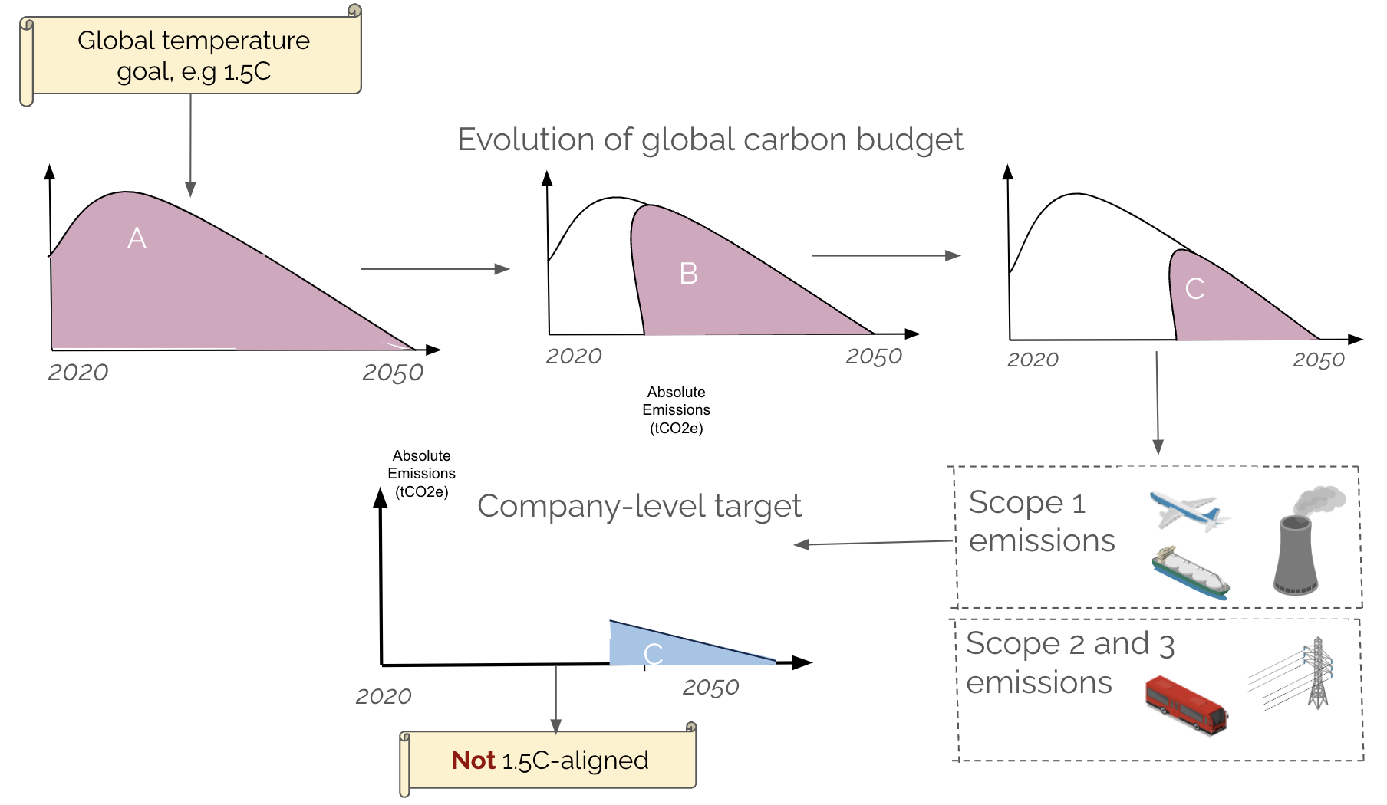

***5.3 Claims for future companies and companies just starting to decarbonise****:*

In the future, providing a 1.5C aligned pathway to a company may imply a very steep reduction curve, one that is not feasible. Therefore, companies may only be able to follow a pathway that leads to higher cumulative emissions beyond the limits of a 1.5C budget.

This evolving constraint suggests that SBTi may no longer validate 1.5°C-aligned targets for all companies. Instead, companies starting to decarbonize now or in later years may only qualify for pathways aligned with higher temperature thresholds (e.g., well below 2°C), reflecting that their cumulative emissions will exceed a 1.5C-aligned budget.

Upon this, the feasibility of 1.5°C claims depends on whether the remaining carbon budget allows for realistic transition pathways that companies can implement without facing extreme disruptions (See illustration below).

1. The Paris Agreement is a legally binding international treaty on climate change, adopted by 196 countries at the United Nations Climate Change Conference (COP21) in Paris, in December 2015. The treaty aims to limit global warming to well below 2°C, preferably 1.5°C, above pre-industrial levels.
2.
3.
4. SBTI, 1.5°C vs. 2°C – a world of difference. https://sciencebasedtargets.org/blog/1-5-c-vs-2-c-a-world-of-difference
5. IPCC, 2023: Climate Change 2023: Synthesis Report. Contribution of Working Groups I, II and III to the Sixth Assessment Report of the Intergovernmental Panel on Climate Change [Core Writing Team, H. Lee and J. Romero (eds.)]. IPCC, Geneva, Switzerland, 184 pp., doi: 10.59327/IPCC/AR6-9789291691647.
6. Forster, P. M., Smith, C., Walsh, T., Lamb, W. F., Lamboll, R., Hall, B., ... & Zhai, P. (2024). Indicators of Global Climate Change 2023: annual update of key indicators of the state of the climate system and human influence. Earth System Science Data, 16(6), 2625-2658.
7.
8. SBTi CNZS
9. The [Corporate Net-Zero Standard](https://sciencebasedtargets.org/net-zero) provides a common, robust, science-based understanding of net-zero. It gives companies clarity and confidence that their near- and long-term decarbonization plans are aligned with climate science by providing a clear, consistent and science-based definition of net-zero.
10. Top-down models provide a macro-level perspective, capturing global emissions trajectories, carbon budgets, and socio-economic interactions. In contrast, bottom-up models focus on detailed sector-specific dynamics, such as technological feasibility and localized mitigation opportunities. A hybrid approach integrates these perspectives, combining the macro-level alignment with global climate goals from top-down models with the detailed, sector-specific insights of bottom-up models
11. https://www.climate-kic.org/wp-content/uploads/2020/09/200902_J932-CKIC-UNEP-ThoughtLeadershipSeries-DrBenCaldecott-1.pdf